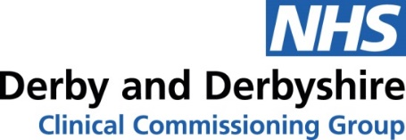

Accessing NHS services over the Christmas and New Year period
The NHS is here to help you over the Christmas and New Year period – so make sure you know your services to get the care you need.
GP practices will generally be closed on the bank holidays, so will not be making appointments for in-person or telephone consultations on those days. Remember 111 online can help you if you have a medical problem which isn't an emergency, and you don't know what to do. Alternatively you can contact the NHS 111 service by dialling 111.
Many pharmacies will also be closed, but some will operate on a rota system to provide cover.
It is a good idea to be prepared for common health problems by keeping a well-stocked medicine cabinet at home.
Prescriptions
Please order any repeat prescriptions you require in time to ensure you have adequate provision over the bank holidays.
GP hours over the bank holidays
Based on an analysis of the demand for services in 2019 and 2020, practices will be offering more appointments at the beginning of the weeks leading up to Christmas and New Year to meet necessary demand and will continue to offer care and services throughout the week.
GP practice services will largely be closed on Monday 27 December, Tuesday 28 December and Monday 3 January. If you need medical advice, please contact NHS 111 through either their online service https://111.nhs.uk or by calling 111.
NHS 111 is available 24 hours a day, 365 days a year. NHS 111 will be able to assess you and point you to the right service for you, based on your symptoms – whether that be to a GP, A&E or self-care – and can arrange a call back from a nurse, doctor or other trained health professional should you need it, to get you the support that you need.
If you are in a life-threatening situation
Please remember that if you have a medical emergency, such as a suspected heart attack, stroke, or other serious life-threatening condition, call 999.
Community pharmacy services over the bank holidays
Some community pharmacies will be open on Monday 27 December, Tuesday 28 December and Monday 3 January. Please check the NHS England website for pharmacy opening times and other useful information about accessing NHS services over the bank holiday period. Alternatively you may wish to visit your pharmacy website or call them for more information.

